System Requirements Specifications

Version : v1

Project Name : Online Shopping

Group Members

Nopa Islam [Id: 011 151 062]

Sukannya Saha [Id: 011 151 079]

Nasir Uddin Ahmed [Id: 011 151 086]

Index

1. Introduction

1.1 Purpose ………………………………………………………………………………

1.2 Scope ………………………………………………………………………………

1.3 System Overview ……………………………………………………………….

1.4 References …………………………………………………………………………

2. Definitions ………………………………………………………………………………

3. Use Case Diagram …………………………………………….......................

4. Activity Diagram …………………………………………………………………….

5. ER Diagram …………………………………………………………………………….

Introduction

**1.1 Purpose**

The purpose of this document is to serve as a guide to designers, developers, and

testers who are responsible for the engineering of the **“Online Shopping”** project. It should

give the engineers all of the information necessary to design, develop, and test the software.

**1.2 Scope**

This document contains a complete description of the functionality of the **“Online Shopping”** project. It consists of use cases, functional requirements, and nonfunctional requirements, which, taken together, form a complete description of the software.

The purpose of **“Online Shopping”** is to ease online based product shopping. The system is based on a relational database. Above all, we hope to provide a comfortable user experience along with the best pricing available.

**1.3 System Overview**

The project has the following features

a. User Account [Log in / Sign Up]

b. Admin Account

c. Product Information

d. Cart

e. Shipping details

f. Merchant Commission

g. Virtual Payment

In short the projects vision is for today’s share economy business remodeling. The fundamental principle of such solution is to enable aggregation on demand from customers online.

**1.4 References**

. SRS IEEE Format: https://web.cs.dal.ca/~hawkey/3130/srs_template-ieee.doc

Definitions

Use Case Diagram

Activity Diagram

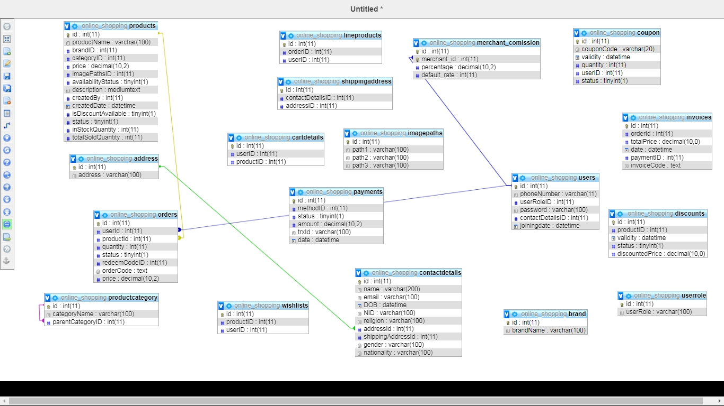ER Diagram

Figure : ER Diagram